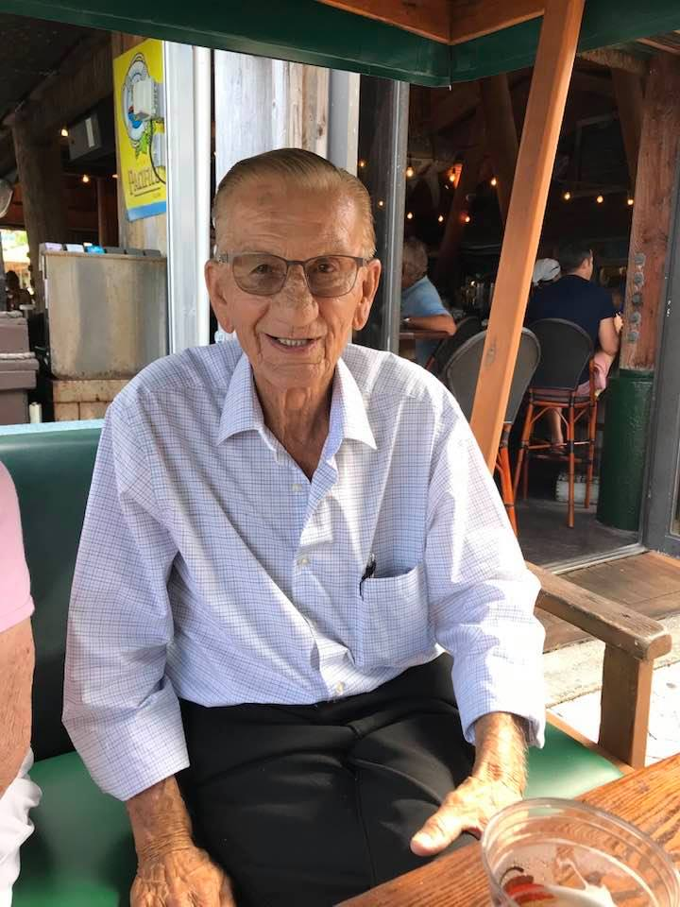ARTHUR G. GENDREAU
6/23/1935-12/20/2021

Arthur was born June 23rd 1935, the son of the late Arthur and Jennie Gendreau in Lowell, Massachusetts. He attended Saint Peter’s Grammar School and graduated from Keith Academy in 1953.
Arthur was also a former Lowell City Counselor and City of Lowell Police Officer. He worked for several years at their family business, Lincoln Square Hardware on Chelmsford St. , Lowell and Prudential Insurance Company of Chelmsford, MA.
He is survived by his wife of 67 years, Sheila A. (Carney).
His four children whom he showed unconditional love for each and every day, Karen L. Kassin, Arthur G. Gendreau III and his wife, Betsy, Susan T. Aspenwall and her partner, Michael Garafola and Joanne A. Gaydos and her husband, Michael. He was predeceased by his daughter, Gail J. Gendreau who died at birth and son in law John H. Kassin in 2006. He is also survived by his grandchildren, Tracey A. Kassin, Arthur P. Gendreau and his wife Becca, Alan S. Gendreau, Aaron J. Gendreau and his wife Claudia, Andrew D. Gendreau, Michael R. Gaydos, Kendall J. and Kara E. Aspenwall. He was predeceased by his oldest grandson, Brian J. Kassin in 2008. He is also survived by his great granddaughter, Callie A. Gendreau, his sisters, Carol A. Villineau, Arlene J. and her husband, Spiros Zousoumas, many nieces and nephews, Godchildren and cousins.
He was also the brother of the late Beatrice A. Wrobel and Francis A. Gendreau. He is also survived by George and Cookie Buote.
At his request, services will be private.

